To use the 8 points of the compass to locate cities in the UK

Note: You will need the map of the UK split into regions. Regions are large areas of land which make it easier for us to have a clear idea roughly where settlements are located.

Scotland and Wales feature as one region. But England has 8: Yorkshire, South West, South East. West midlands, East midlands, north west, north east and East Anglia.
Use the compass below to help you locate on your map the regions. There’s a clue in the location of it as for the name E.G East midlands suggests in the east but also the middle of the country. (just be careful not to confuse it with East Anglia)

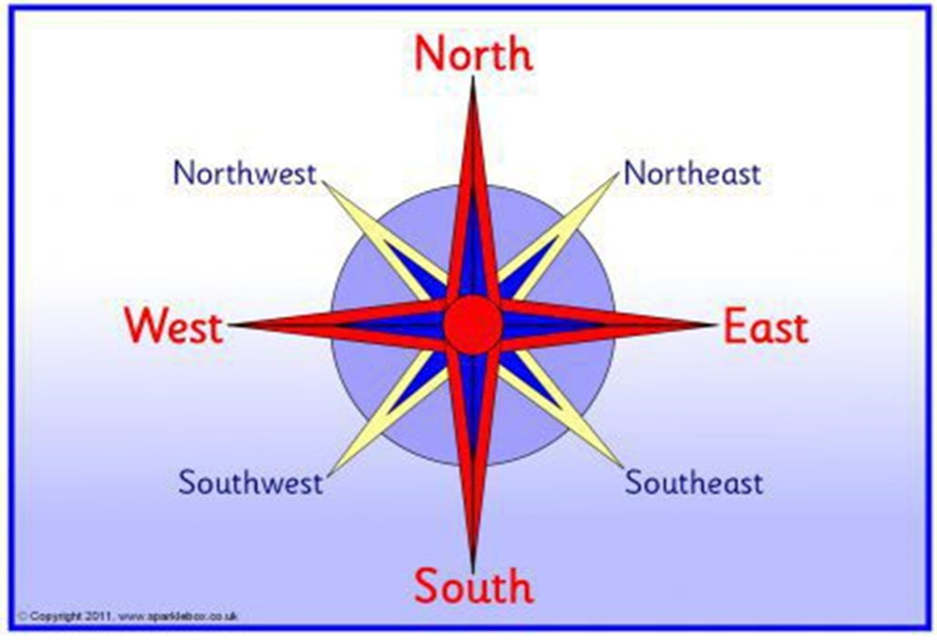
Locate and label each region using a key. Colour the regions in different colours and show this in the key. Like I’m about to do on my picture below.

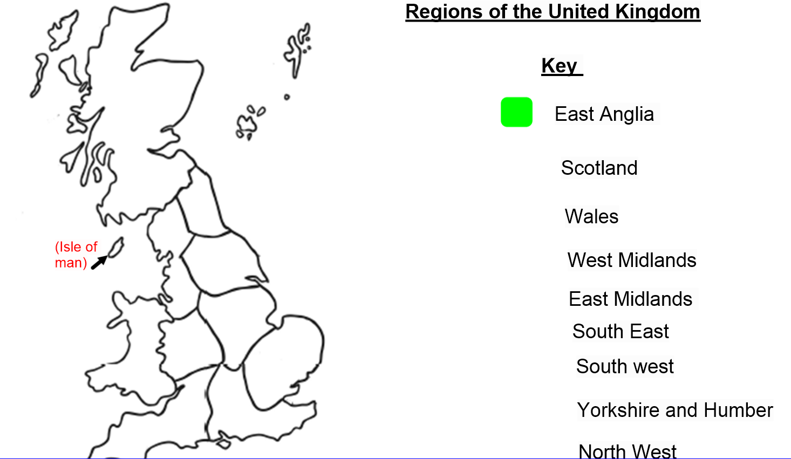

When you’ve done that, you’ll need an atlas (not Goggle maps!) to use the clues to locate the city. Once you’ve found it, draw a dot where it is located on the map and neatly draw a line to that dot and write the city name. These are the cities I’d like you to find.

Birmingham - West midlands
Coventry - West midlands
Canterbury - South East
London - South East
Bristol - South West
Cambridge - East Anglia
Liverpool - North West
York - Yorkshire and Humber
Newcastle - North East
Leeds - Yorkshire and Humber
Manchester - North west
Nottingham - East midlands
Plymouth - South West
Norwich - East Anglia
Cardiff - Wales (south)
Edinburgh – Scotland

Now you’ve done that, try to answer these questions in FULL sentences. Please put this title too

To apply positional language to describe and compare locations

Example - 'What region is Norwich in?'
Norwich is East Anglia.

1) Name three places in the South-East other than London

2) Find Bristol in the South-West. Describe the compass direction from Bristol to Birmingham.

3) Leeds is in Yorkshire; what direction would you need to go in to get to Liverpool.

4) What direction is Newcastle (booo!) from Birmingham?

5) (Southampton is on the south coast) What direction is London from Southampton?

6) Find London. Name a place which is North-west of it.

7) What place would you say is the most Easterly point in the UK you can get (use a ruler to help you compare)

8) Find London, what direction is Wales from it?

