

**Packaging**

Have a look at some of the food items in your home. What is the packaging like? What material is it made from? What information does it have on it? Which do you like best? Why?

**Design your own packaging. Think about:**

* What product will your packaging contain?
* What is the purpose of the packaging?
* What shape will it be?
* What materials will you use?
* Will you consider the environment when you make your choice?
* What information will you include on it?
* What colours, patterns will you use?







Labelled picture of my package design

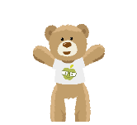

Have a go at making your packaging!