**Her new club will commence on Monday 17th January.**

**(please see attached letter from Mrs Lyall regarding art club)**

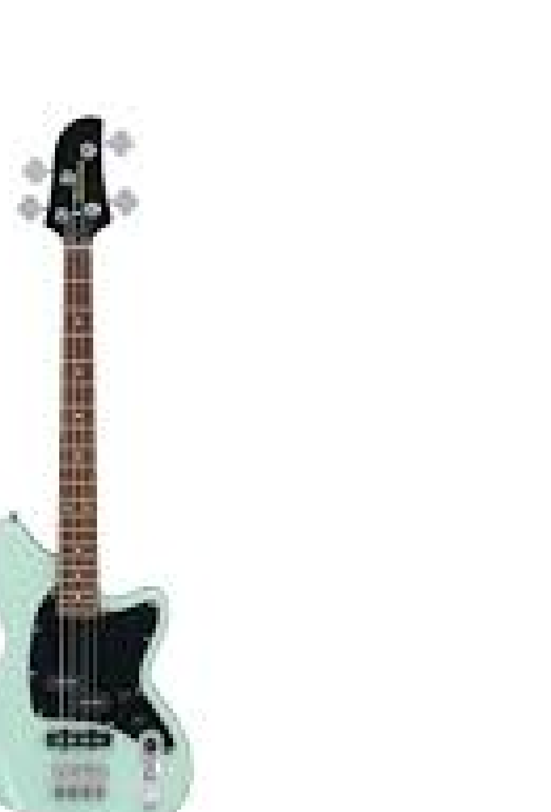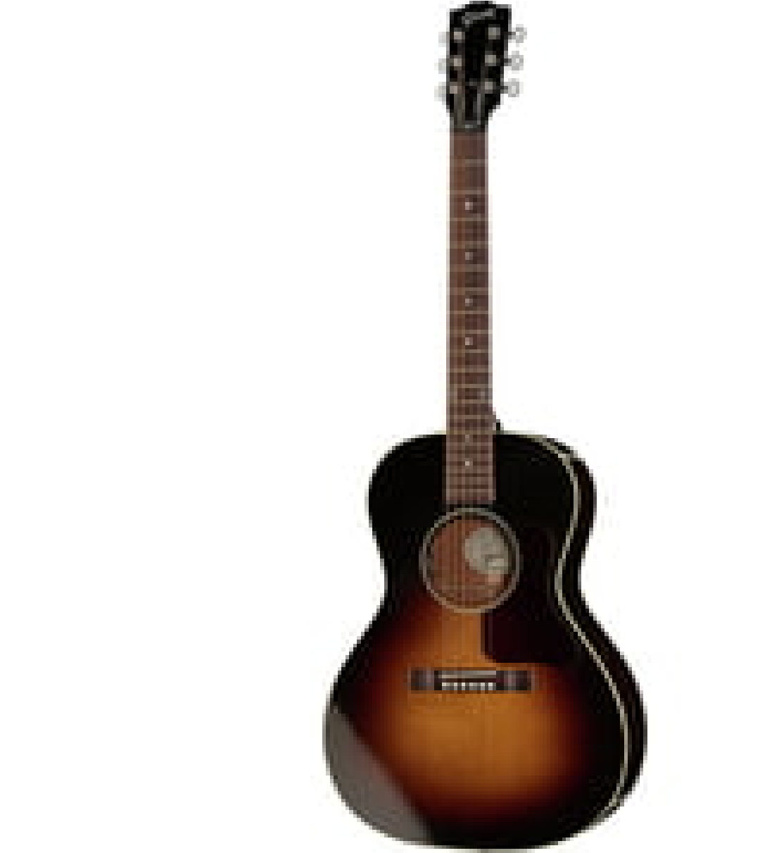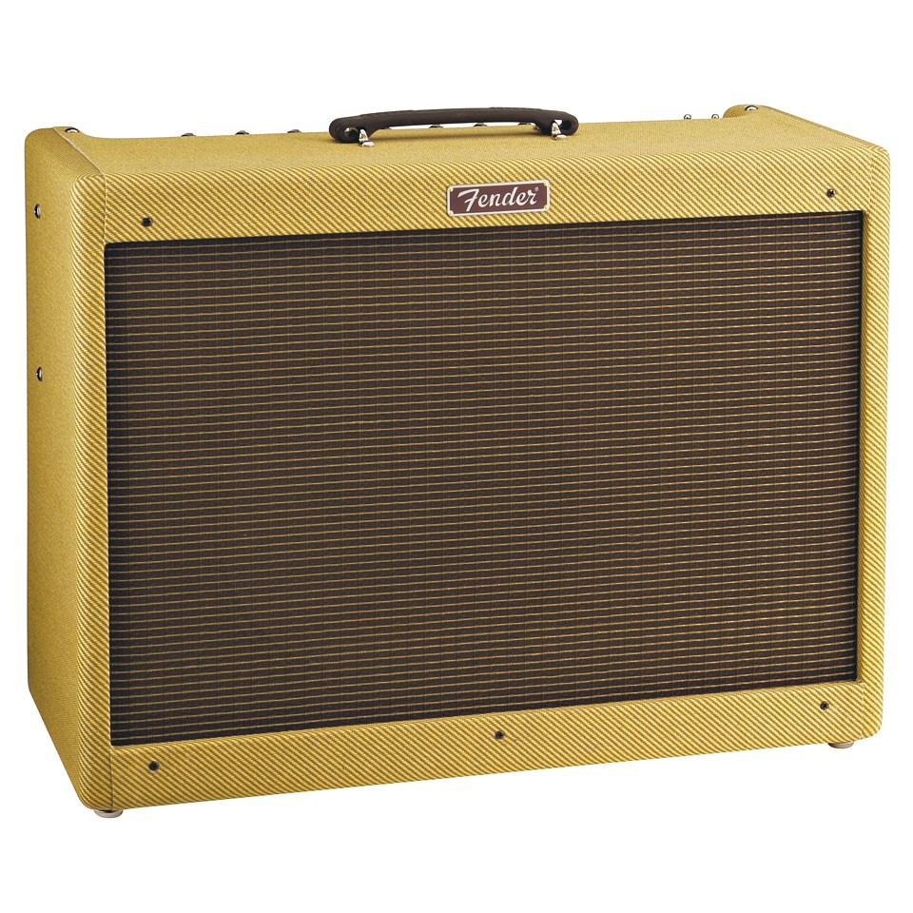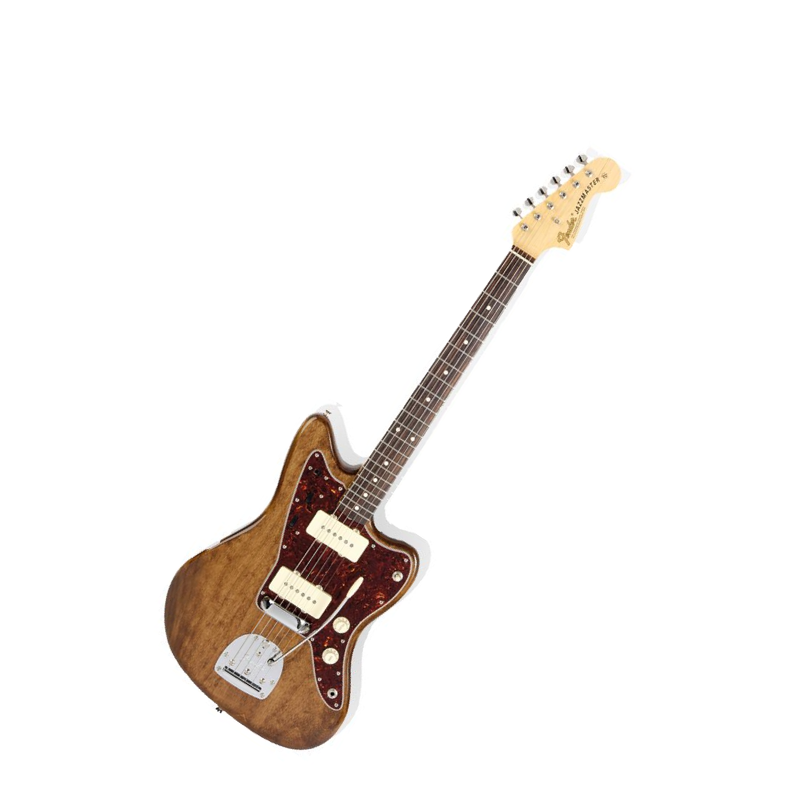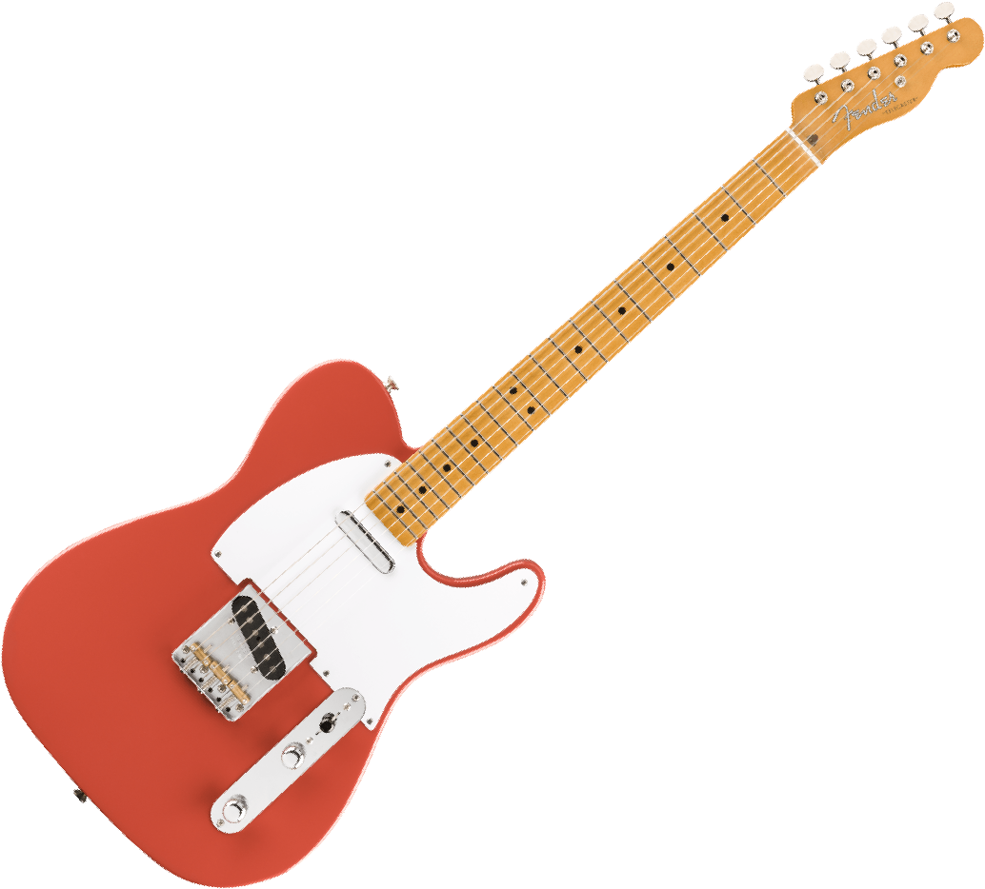

**Learn the Guitar at School!**

Acoustic, Electric, Bass Guitar and Ukulele lessons available

**Now Recruiting!**

For further information

Contact

Mike Rudland-Simpson

mike.schoolofguitar@hotmail.com

07921806670

