

**Prime Minister for the day!**

Imagine you are going to be the Prime Minister for the day! Create a timetable with all the things you plan to do. Think about:

* What time will you get up?
* Will you schedule in mealtimes and breaks?
* Will you plan to change any rules or laws?
* Will you use the Voyager aircraft?
* Do you plan to address the nation?

Use the timetable below or create your own.

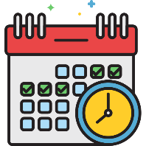

|  |  |
| --- | --- |
| Time | What you are doing |
|  |  |
|  |  |
|  |  |
|  |  |
|  |  |
|  |  |
|  |  |



Decide whether to record your times in 12 or 24-hour clock.