NAME: |  | FORM:

Six-Figure Grid References

Instructions:
Look at the figure below. What is at the following grid references?

276704 _______________________________  285715 _______________________________  272693 _______________________________ | 283692 _______________________________  288717 _______________________________  285705 _______________________________

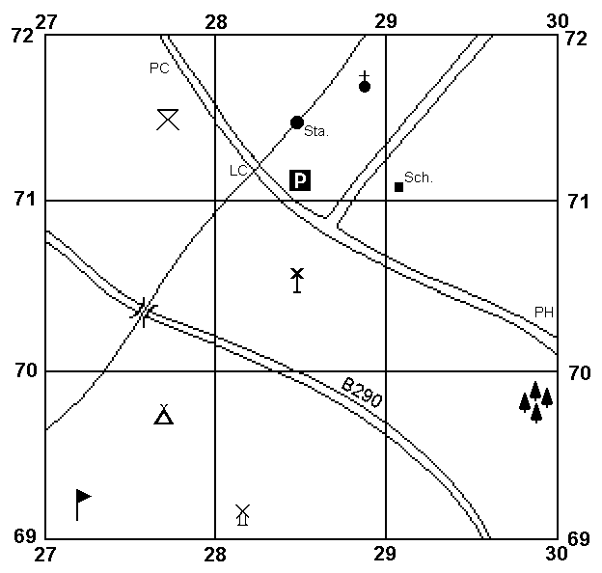
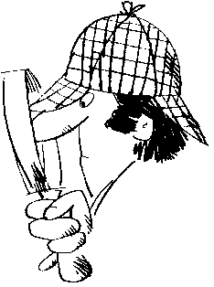

List the six-figure grid references for the following map features.

School |  | Wood
Public House (ph) |  | The ‘B’ in B290
Campsite |  | Picnic Site
Level Crossing |  | Car Park

