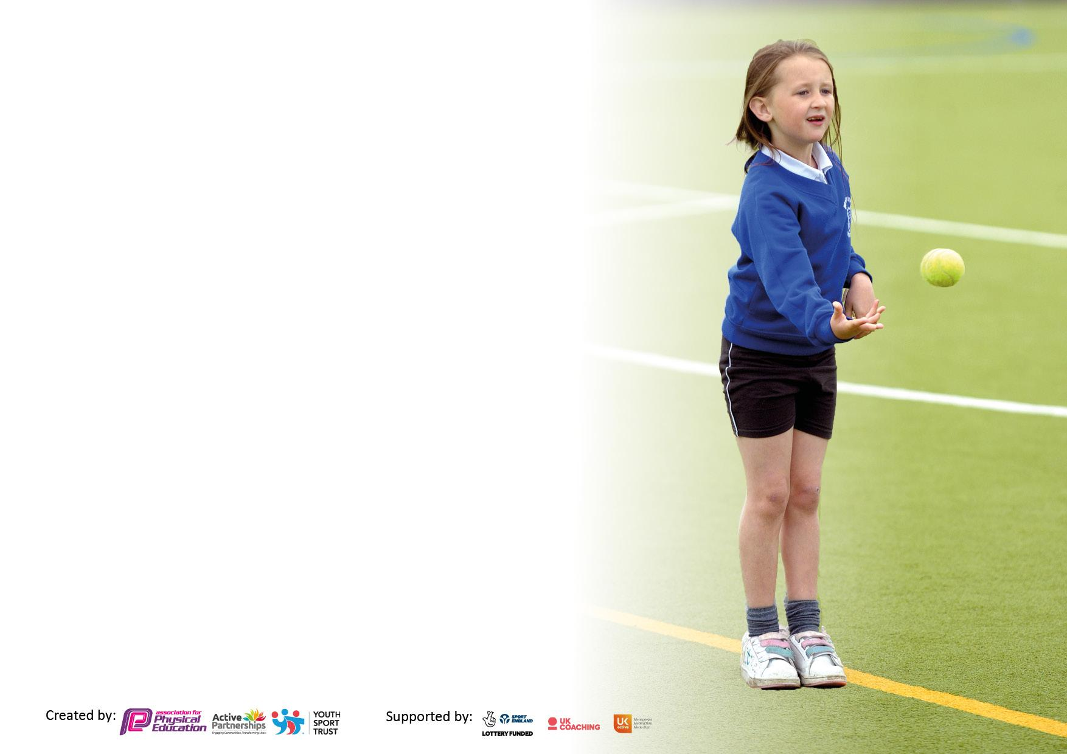

It is important that your grant is used effectively and based on school need. The [Education Inspection Framework](https://www.gov.uk/government/publications/education-inspection-framework) makes clear there will be a focus on **‘whether leaders and those responsible for governors all understand their respective roles and perform these in a way that enhances the effectiveness of the school’**.

Under the Quality of Education judgement, Ofsted inspectors consider:

**Intent** - Curriculum design, coverage and appropriateness

**Implementation** - Curriculum delivery, teaching (pedagogy) and assessment

**Impact** - Attainment and progress

To assist schools with common transferable language, this template has been developed to utilise the same three headings which should make your plans easily transferable between working documents.

Schools must use the funding to make additional and sustainable improvements to the quality of Physical Education, School Sport and Physical Activity (PESSPA) they offer. This means that you should use the Primary PE and sport premium to:

* Develop or add to the PESSPA activities that your school already offers
* Build capacity and capability within the school to ensure that improvements made now will benefit pupils joining the school in future years
* The Primary PE and sport premium should not be used to fund capital spend projects; the school’s budget should fund these.

Please visit <https://www.gov.uk/guidance/pe-and-sport-premium-for-primary-schools> for the revised DfE guidance, including the 5 key indicators across which schools should demonstrate an improvement. This document will help you to review your provision and to report your spend. DfE encourages schools to use this template as an effective way of meeting the reporting requirements of the Primary PE and Sport Premium.

We recommend you start by reflecting on the impact of current provision and reviewing the previous spend.

Schools are required to publish details of how they spend this funding, including any underspend from 2021/2022, as well as on the impact it has on pupils’ PE and sport participation and attainment.

We recommend regularly updating the table and publishing it on your website throughout the year. This evidences your ongoing self-evaluation of how you are using the funding to secure maximum, sustainable impact. Final copy must be posted on your website by the end of the academic year and no later than the 31 July 2023.



|  |  |
| --- | --- |
| Total amount allocated for 2022/23 across the Federation | £33,420.00 (16000 per school +£10 per child) |
| Total amount of funding for 2022/23 to be reported on by 31st July 2023 | £33,420.00 |



|  |  |
| --- | --- |
| Meeting national curriculum requirements for swimming and water safety.  **N.B.** Complete this section as best you can. For example, you might have practised safe self-rescue techniques on dry land which you can then transfer to the pool when school swimming restarts.  **Due to exceptional circumstances priority should be given to ensuring that pupils can perform safe self-rescue even if they do not fully meet the first two requirements of the NC programme of study** | 100% |
| What percentage of your current Year 6 cohort swim competently, confidently and proficiently over a distance of at least 25 metres?  **N.B.** Even though your pupils may swim in another year, please report on their attainment on leaving primary school at the end of the summer term 2023.  Please see note above | 100% |
| What percentage of your current Year 6 cohort use a range of strokes effectively [for example, front crawl, backstroke and breaststroke]?  Please see note above | 100% |
| What percentage of your current Year 6 cohort perform safe self-rescue in different water-based situations? | 100% |
| Schools can choose to use the Primary PE and sport premium to provide additional provision for swimming, but this must be for activity **over and above** the national curriculum requirements. Have you used it in this way? | Yes- all children in KS1 and 2 have undertaken 1 term of swimming |



|  |  |  |  |  |
| --- | --- | --- | --- | --- |
| **Academic Year:** 2022/23 | **Total fund allocated:**£33,420.00 | **Date Updated:July 2022** | |  |
| **Key indicator 1:** The engagement of all pupils in regular physical activity – Chief Medical Officers’ guidelines recommend that  primary school pupils undertake at least 30 minutes of physical activity a day in school | | | | Percentage of total allocation: |
| % |
| **Intent** | **Implementation** | | **Impact** |  |
| Your school focus should be clear on what you want the pupils to know and be able to do. What do they need to learn and to consolidate through practice: | Make sure your actions to achieve are linked to your intentions: | Funding allocated: | Evidence of impact:  What do pupils now know and what can they now do? What has changed? | Sustainability and suggested next steps: |
| Pupils are aware of the importance of regular physical activity and can explain the benefits of this, including how it makes them feel. | Improved resources  Continue forest school activities so all children access forest school learning for at least half a term per year.  To increase amount of time the children are active in school to a minimum of 30 mins at playtimes and lunchtimes  To provide opportunities for active learning during the school day. Use of BBC Supermovers, GoNoodle, etc for active brain breaks. | £4000  £3724 per school (£7448) | Children have access to quality resources  All children involved in Forest School activities  Sports Crew have taken initiative to lead activities and make use of a range of resources at play times.  Brain breaks are a normal part of the school day. | Invest in equipment for PE lessons and playtimes will ensure that games can be established that will engage pupils being active.  Pupils develop skills over time and are engaged in outdoor learning that enhances and compliments the national curriculum.  Next Steps: rota of equipment in order to encourage children to engage in a broader range of activities.  Staff meeting training to ensure that all staff are aware of integrating 30 active minutes into the school day. |
| **Key indicator 2: The profile of PESSPA being raised across the school as a tool for whole school improvement** | | | | Percentage of total allocation: |
| % |
| **Intent** | **Implementation** | | **Impact** |  |
| Your school focus should be clear on what you want the pupils to know and be able to do. What do they need to learn and to consolidate through practice: | Make sure your actions to achieve are linked to your intentions: | Funding allocated: | Evidence of impact:  What do pupils now know and what can they now do? What has changed? | Sustainability and suggested next steps: |
| Encourage pupils to take on leadership roles that support sport and physical activity in school – sports captains and play leaders  Ensure that all children are aware of the importance of a healthy lifestyle in diet and regular exercise.  Noticeboard in main hall to raise the profile of PE for all parents and visitors. Raise the profile of PESSPA by Presenting awards and certificates from both in-school and out-ofschool activities. | Support new leaders and sport captains to effectively support sport provision in school.  Embed teaching within spring term of the PSHE scheme. Well being week Focus on healthy living through PSHE and science  Subject leaders to maintain.  Sports Crew take turns to present children in school with ‘Sports Crew Awards.’ This is supported by Sporting Influence.. Children are encouraged to bring in medals and certificates from home to share in their achievements. | £500 | Children are positive about play leader and captain roles  Well being week feedback and work in PSHE books demonstrates appropriate understanding.  Encourage less active children to try new sports | Provide opportunities for a wider range of games  Continue to focus on well being and make links with Thrive.  Celebrates individual and team success – improved engagement and participation. |

|  |  |  |  |  |
| --- | --- | --- | --- | --- |
| **Key indicator 3:** The profile of PE and sport is raised across the school as a tool for whole school improvement | | | | Percentage of total allocation: |
| % |
| **Intent** | **Implementation** | | **Impact** |  |
| Your school focus should be clear on what you want the pupils to know and be able to do. What do they need to learn and to consolidate through practice: | Make sure your actions to achieve are linked to your intentions: | Funding allocated: | Evidence of impact:  What do pupils now know and what can they now do? What has  changed? | Sustainability and suggested next steps: |
|  |  |  |  |  |
|  |  |  |  |  |
|  |  |  |  |  |
|  |  |  |  |  |
| Work with SI (Sporting Influence) to upskill teachers.    Allow PLTs time to meet to work on implementation of PE across the Fed.  Create new long-term plan to enable better provision for PE . | Staff teach alongside SI Coaches and develop their teaching, planning, and delivery skills for PE. Coaches offer advice and support where needed  Dedicated subject leader time planned into the calendar to ensure time to plan and monitor impact.  To work with SI coach to develop a new LTPlan based on a progression of key knowledge and skills | £9720 per school (£19440)  £2000 | Further confidence in staff teaching PE. Staff involved in leading parts of lessons and KS2 staff using these to teach PE lessons when SI coach not teaching.  `Impact is being monitored and appropriate training identified.  Staff are working from a more comprehensive document. | Develop teachers confidence in planning Pe lessons to develop skills in small sequential steps for all learners. Improved confidence in teaching PE  This is built into the moderation timetable for the Federation.  Create a new progression and skills map |
| **Key indicator 4:** Broader experience of a range of sports and physical activities offered to all pupils | | | | Percentage of total allocation: |
|  |
| **Intent** | **Implementation** | | **Impact** |  |
| Your school focus should be clear on what you want the pupils to know and be able to do. What do they need to learn and to consolidate through practice: | Make sure your actions to achieve are linked to your intentions: | Funding allocated: | Evidence of impact:  What do pupils now know and what can they now do? What has  changed? | Sustainability and suggested next steps: |
|  |  |  |  |  |
|  |  |  |  |  |
|  |  |  |  |  |
|  |  |  |  |  |
| Engage in competitions  Children enjoy a rich range of extra-curricular opportunities through clubs and links with other schools and organisation | Take part in competitions and festivals in the cluster and local area  Provide a range of free after school opportunities to ensure inclusion. Clubs run by school staff and external providers if appropriate | Part of SI contract | Record of sporting events attended shows that children have had the opportunity to attend a broad range of sports  Regular calendar of clubs throughout the year | Pupils engage in different sports and develop their understanding and desire to participate in a broad range of games.  JF already introduced Tchoukball to the Federation |

|  |  |  |  |  |
| --- | --- | --- | --- | --- |
| **Key indicator 5:** Increased participation in competitive sport | | | | Percentage of total allocation: |
| % |
| **Intent** | **Implementation** | | **Impact** |  |
| Your school focus should be clear on what you want the pupils to know and be able to do. What do they need to learn and to consolidate through practice: | Make sure your actions to achieve are linked to your intentions: | Funding allocated: | Evidence of impact:  What do pupils now know and what can they now do? What has  changed? | Sustainability and suggested next steps: |
|  |  |  |  |  |
|  |  |  |  |  |
|  |  |  |  |  |
|  |  |  |  |  |
| To participate in the competitive ‘School Games’ events  All children had the opportunity to be involved in our whole school sports day. | PE lead and coach met this objective by offering a wide range of afterschool clubs and holding in house competitions. | Part of SI contract | All children can compete in competitive sport suited to their ability. House competitions held for children of all abilities. Sports day also involves all children. | Pupils understand the importance of competitive sport in school. Improve links with clubs outside of school to promote sporting activity and competitiveness. To develop in school competitions to include a wider range of sports/activities to make them more engaging for all children. |

|  |  |
| --- | --- |
| Signed off by | |
| Head Teacher: | PAcheson |
| Date: | July 23 |
| Subject Leader: | Mark Gamble/Jenny Field |
| Date: | July 23 |
| Governor: | Rachel Bain |
| Date: | July 23 |