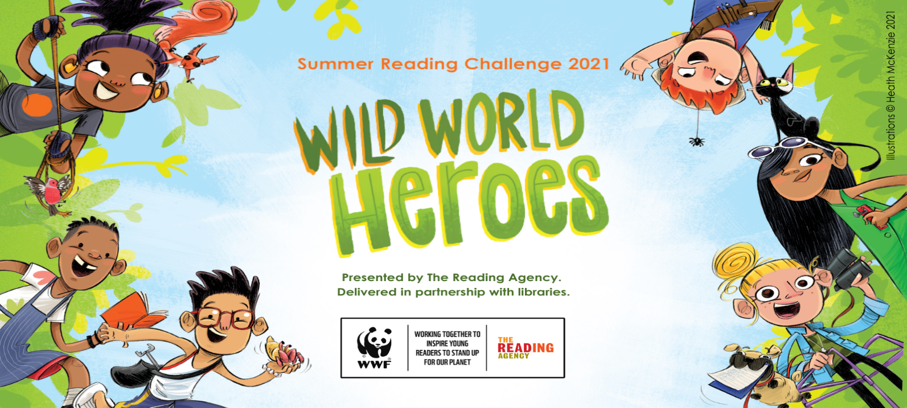
Go Green with the Summer Reading Challenge 2021!
Children can once again sign up for the Summer Reading Challenge at their local library during the holidays. This year the theme is Wild World Heroes and is all about nature and looking after the planet.
The challenge is to read 6 library books of their choice and collect special stickers and other prizes along the way – everyone who finishes will receive a limited edition Wild World Heroes medal and a certificate. Any child aged 4 to 11 can join in and the challenge runs from Sat 10th July until Sat 11th Sept.
There will also be a fantastic programme of online activities to go with the challenge – whilst there will be some pre-recorded activities available on the @nycclibraries Facebook page, many of the activities will require bookings to be made via eventbrite (see attached flyer)
Some libraries may be able to have events in the library, depending on Covid restrictions – just ask at your local branch.

