NAME:
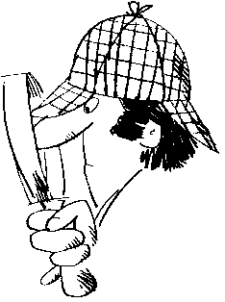
Four and Six-Figure Grid References
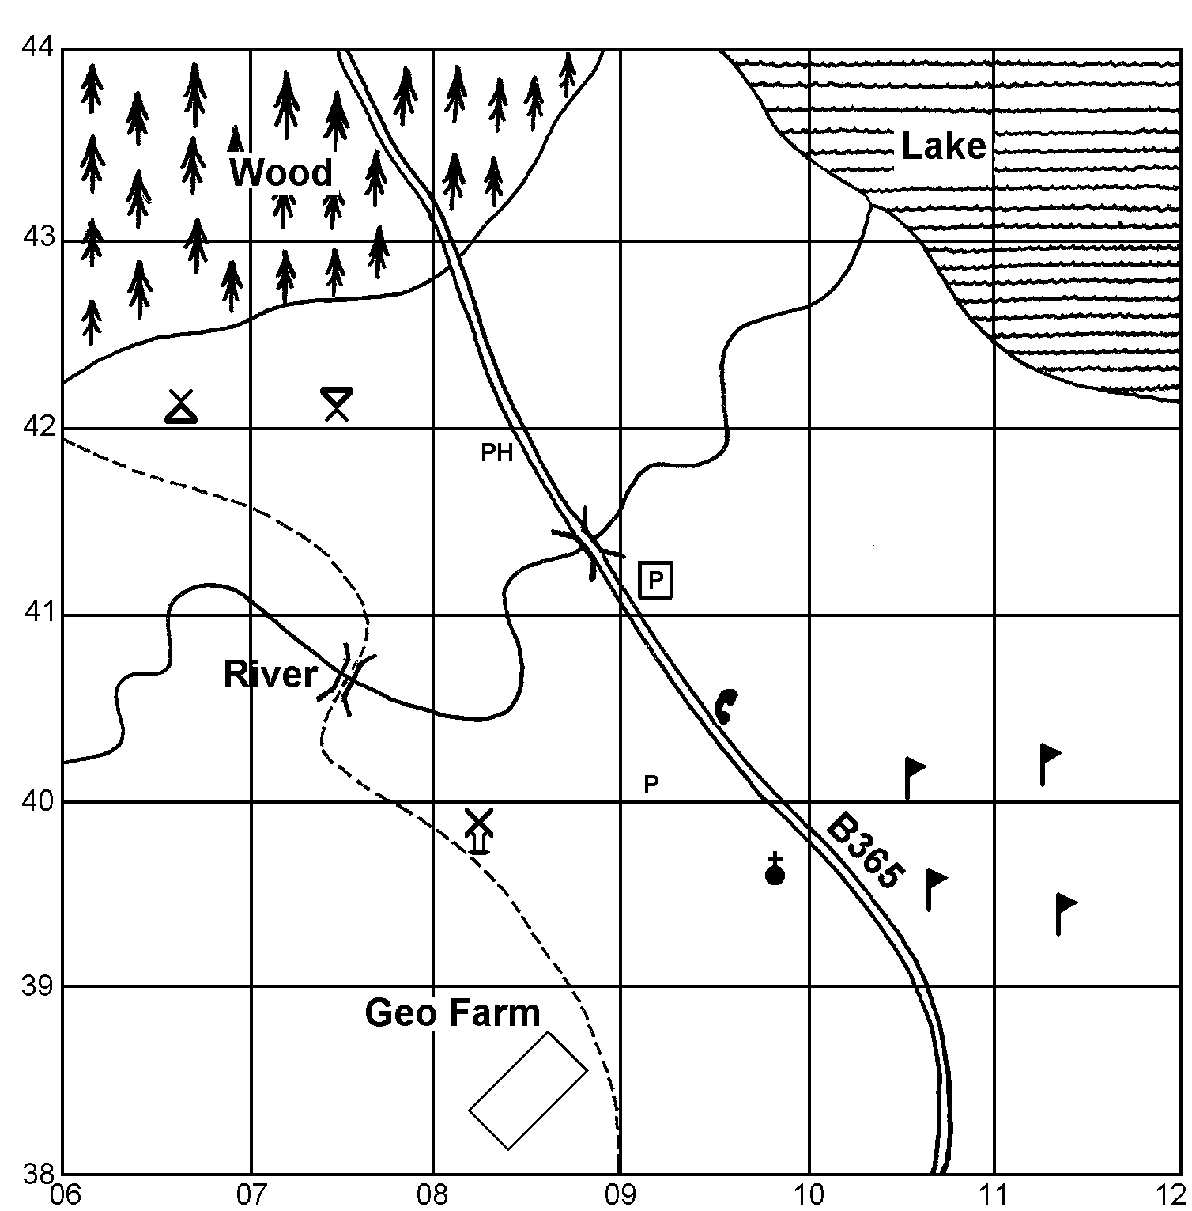

KEY:
Wood
Lake
Secondary
Road
Bridge
Camp Site
Parking
Picnic Site
PH Public House
P Post Office
Golf Course
Place of worship
with spire
Public Telephone
Windmill

1. Give a 4-figure grid reference to locate the lake _________________.
2. Give a 4-figure grid reference to locate part of the wood _________________.
3. Give a 4-figure grid reference for a bridge _________________.
4. Give a 4-figure grid square containing part of the golf course _________________.

5. Answer; public telephone, windmill, car park, place of worship with spire, post office or public house to the following questions;
(a) The is in square 0839. | (b) The is in square 0841.
(c) The is in square 0939. | (d) The is in square 0941.

6. Give the 6-figure grid references for the following;
(a) Camp site | (b) Picnic site |  | (c) Post office
(d) Parking | (e) Windmill |  | (f) Public house
(g) Place of worship with spire |  | (h) Public telephone

