Dear Parents,
As the weather is still unpredictable at the moment, it is important that the children have the correct kit to take part in forest School so please take note of the forecast on a Forest School day. a
Essential kit each week:
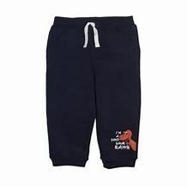
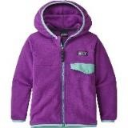
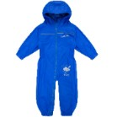
Old clothes- tracksuit bottoms/ leggings and jumper such as a fleece

Waterproof all in one suit or waterproof trousers and a waterproof coat

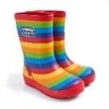
Extra pair of socks

Wellies

A plastic bag or two to take home muddy clothes

On colder days:

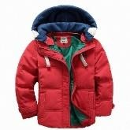
A warm coat to wear under a waterproof coat.

On sunny days:

A sun hat/ cap

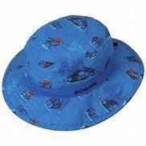
Sun cream applied before school/ prior to the session.

No shorts please as the children will be kneeling on the ground and using sharp tools.

Thank you for your cooperation
The Outdoor Adventures Forest School Team.

