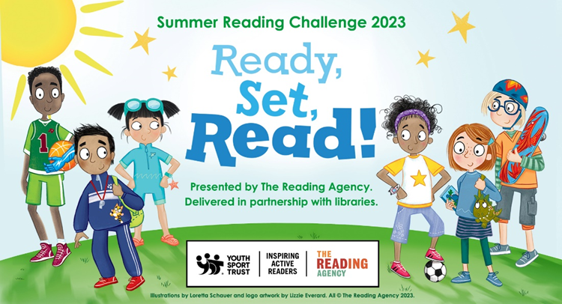
Get active with the Summer Reading Challenge 2023!
Children can once again sign up for the Summer Reading Challenge at their local library during the holidays. This year the theme is Ready Set Read! and is all about the power of play, sport, games and physical activity.
The challenge for children is to read 6 library books of their choice and collect special stickers and other prizes along the way – everyone who finishes will receive a limited-edition Ready Set Read! medal and a certificate. Any child aged 4 to 11 can join in and the challenge runs from Sat 15th July until Sat 9th Sept.
There will also be a fantastic programme of activities in libraries all summer, many of them free, to go with the challenge – look out for flyers with more details which have been sent to schools for children to bring home.

