Dear Parents,
Class 3 will continue to do Forest School week commencing 12th April - week ending 14th May. It will then change to class 2 week commencing 17th May - week ending 23rd July.
It is essential they have the correct kit as we go off site and the field is often wet and very muddy. They must have wellies and waterproofs each week.
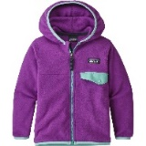
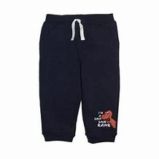
Essential kit each week:
Old clothes- tracksuit bottoms and thick jumper such as a fleece

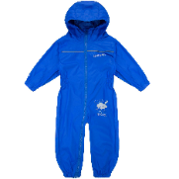
Waterproof all in one suit or trousers and a waterproof coat
Extra pair of socks
Wellies
A plastic bag or two to take home muddy clothes

In very cold weather:

Hat, gloves, snood
A warm base layer under clothing- leggings and long sleeve top (or some children may already have football skins or thermal base layers)
A thick winter coat

