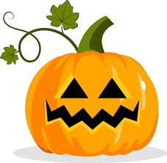
HALLOWEEN LUNCH
Wednesday 25th October
Spooky Sandwitch
Ham or Cheese
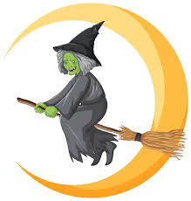
Mummified Sausage
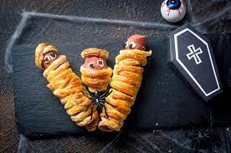
Vegetable Sticks with Vampire Repellent
(garlic mayo)
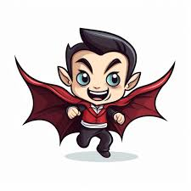
Halloween Cookie
