St James and the Methodist Church,
Grewelthorpe
Events and services for Christmas 2022
Please join us if you can
Wishing you a very Happy Christmas and Peaceful New Year.
From all the Church community.

Monday, 6th December 10.30-3pm

Christmas Carol Service
Sunday, 18th December, 6pm
followed by Mulled wine and mince pies.

G Club Christmas party 14th December 6-7pm
Contact susan.rizos@btinternet.com

Family Christingle Service
Sunday, 11th December 6pm
This is a lovely service especially suitable for Children.

Christmas Day Services
Not a service in Grewelthorpe but you will be welcome to any of the other services in the Benefice

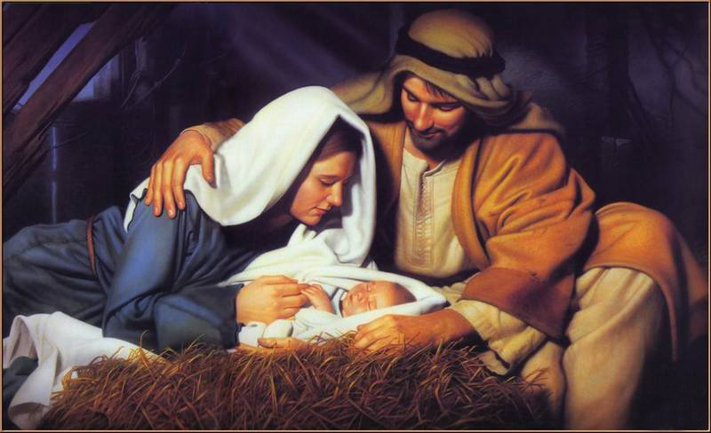
Christmas Feast
10th December, 7pm Festive meal and bar Contact susan.rizos@btinternet.com or Tel 658200 for tickets
Epiphany Party
6th January 2022 7pm in Grewelthorpe Church

