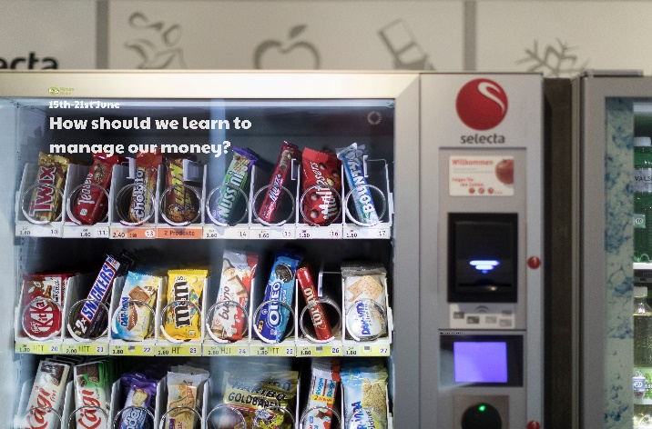

Use a magnet (you may have one on your fridge at home) to find out which coins are magnetic, and which are not. Use the website link to find out why some are, and some are not! [www.fun-science.org.uk/magnetic-coins-science-experiment](http://www.fun-science.org.uk/magnetic-coins-science-experiment)

Imagine you are allowed to choose one thing to buy. You can have anything you would like, and it doesn’t matter how much it costs. Draw a picture and write a description of your item.

Design and make a money box or a purse to look after your money!

Find out about coins and notes used in the UK in the past. Does anyone in your family remember coins changing and new ones being introduced? What is a shilling?

Each country has its own currency. This is the system of money it uses. The currency used in the UK is called pound sterling. Find out the currency used in other countries of the world. Locate the countries on a world map.

Look at the graph showing the average value of pocket money per week in the UK, found on resource 2. How much does the average 12-year-old receive? What is the age of the children who receive an average pocket money of £4.60 per week? Which age receives the most/least? How much more does a 13-year-old receive than a 5-year-old? What coins could you use to pay a 6-year-old the average weekly pocket money?

**Learning from Home**

Use the ideas below, alongside this week’s resource, to support your home learning.